## **Task 1. Explore data with Wireshark**

In this task, you must open a network packet capture file that contains data captured from a system that made web requests to a site. You need to open this data with Wireshark to get an overview of how the data is presented in the application.

1. To open the packet capture file, double-click the **sample** file on the Windows desktop. This will start Wireshark.

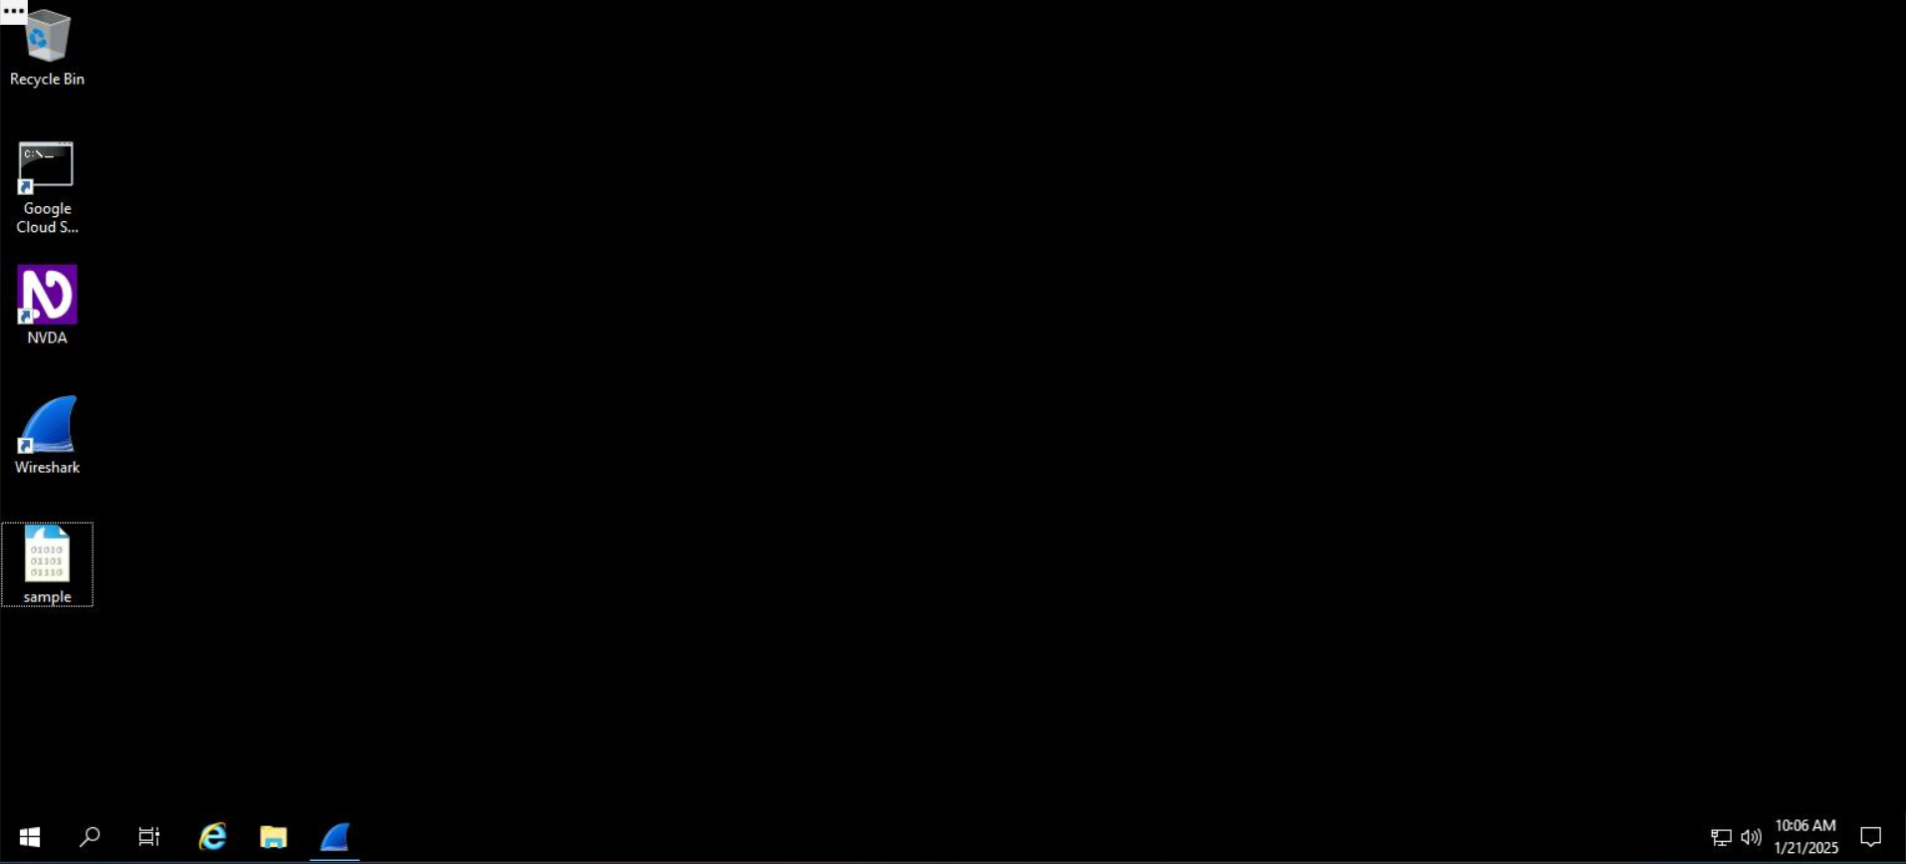

2. Double-click the Wireshark title bar next to the **sample.pcap** filename to maximize the Wireshark application window.

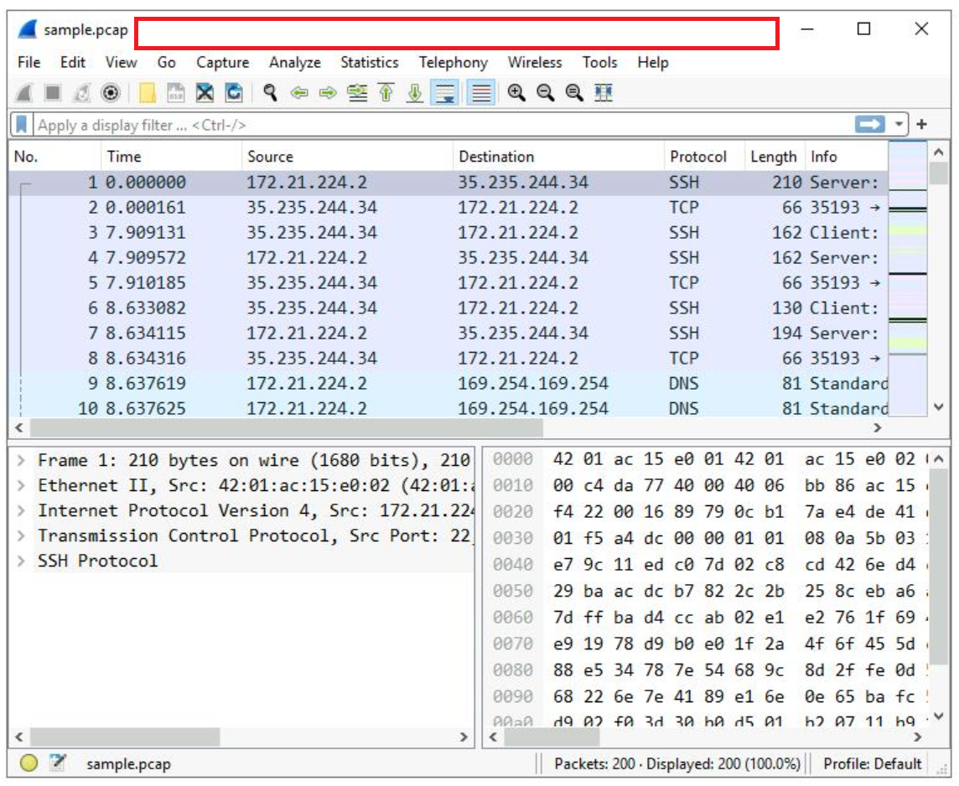

1. Scroll down the packet list until a packet is listed where the info column starts with the words 'Echo (ping) request'.

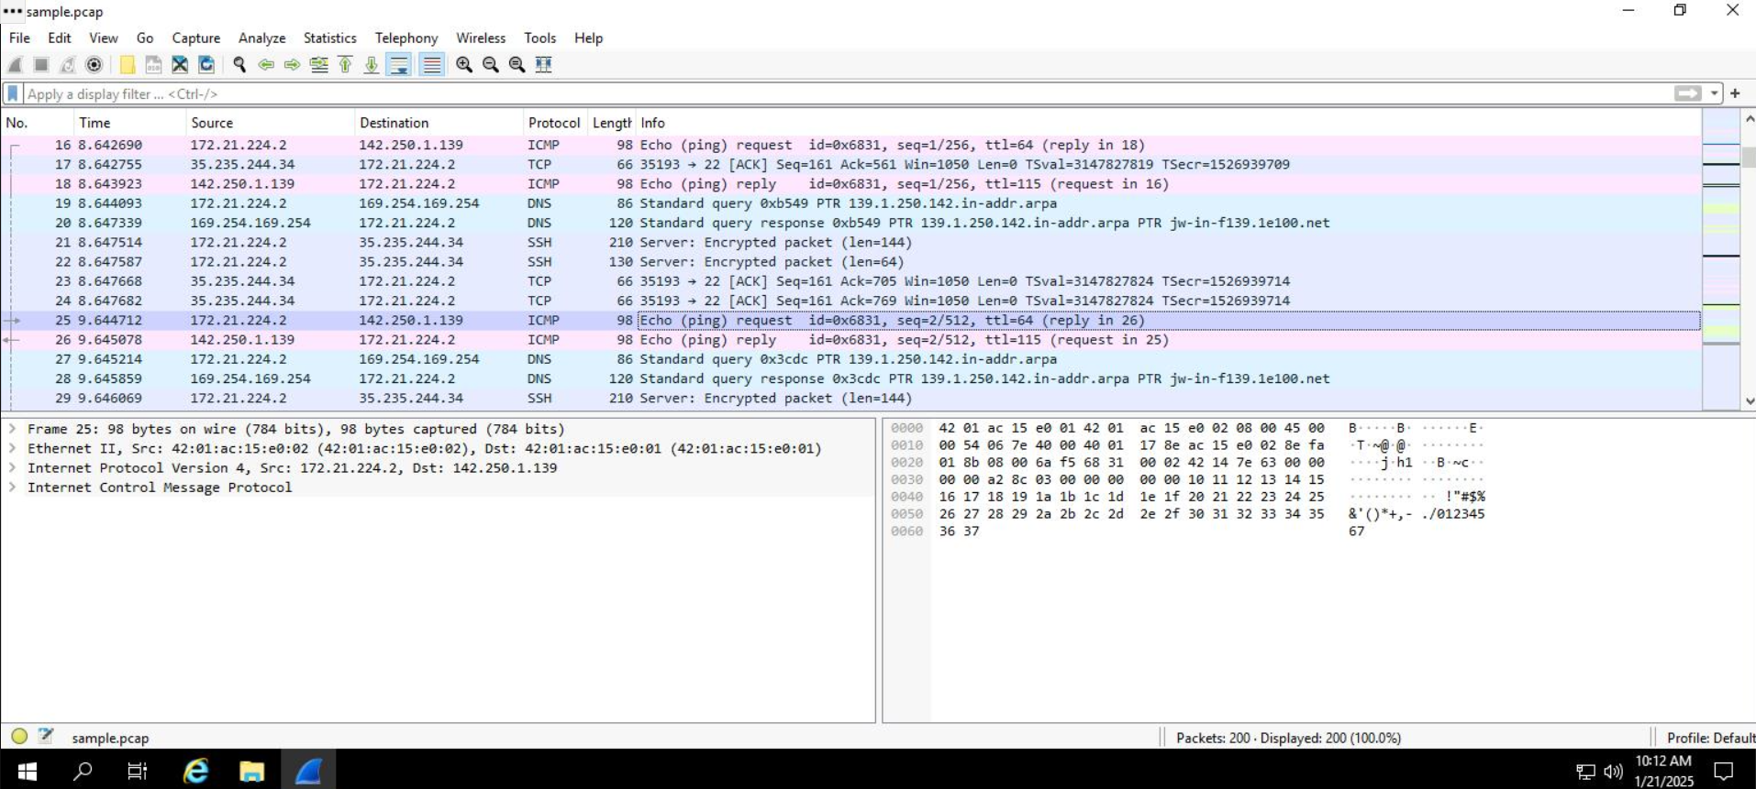

## **Task 2. Apply a basic Wireshark filter and inspect a packet**

In this task, you’ll open a packet in Wireshark for more detailed exploration and filter the data to inspect the network layers and protocols contained in the packet.

1. Enter the following filter for traffic associated with a specific IP address. Enter this into the **Apply a display filter...** text box immediately above the list of packets:

ip.addr == 142.250.1.139

Copied!

content_copy

1. Press **ENTER** or click the **Apply display filter** icon in the filter text box.

The list of packets displayed is now significantly reduced and contains only packets where either the source or the destination IP address matches the address you entered. Now only two packet colors are used: **light pink** for ICMP protocol packets and **light green** for TCP (and HTTP, which is a subset of TCP) packets.

1. Double-click the first packet that lists **TCP** as the protocol.

This opens a packet details pane window:

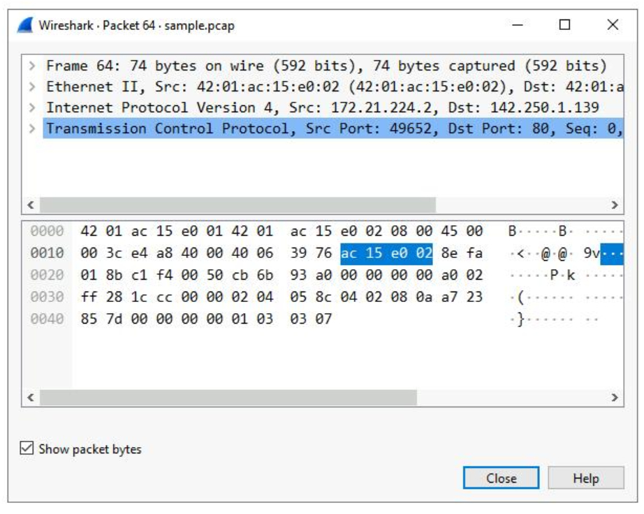

The upper section of this window contains subtrees where Wireshark will provide you with an analysis of the various parts of the network packet. The lower section of the window contains the raw packet data displayed in hexadecimal and ASCII text. There is also placeholder text for fields where the character data does not apply, as indicated by the dot (“.”).

***Note:*** *The details pane is located at the bottom portion of the main Wireshark window. It can also be accessed in a new window by double clicking a packet.*

1. *Double-click the first subtree in the upper section. This starts with the word* ***Frame****.*

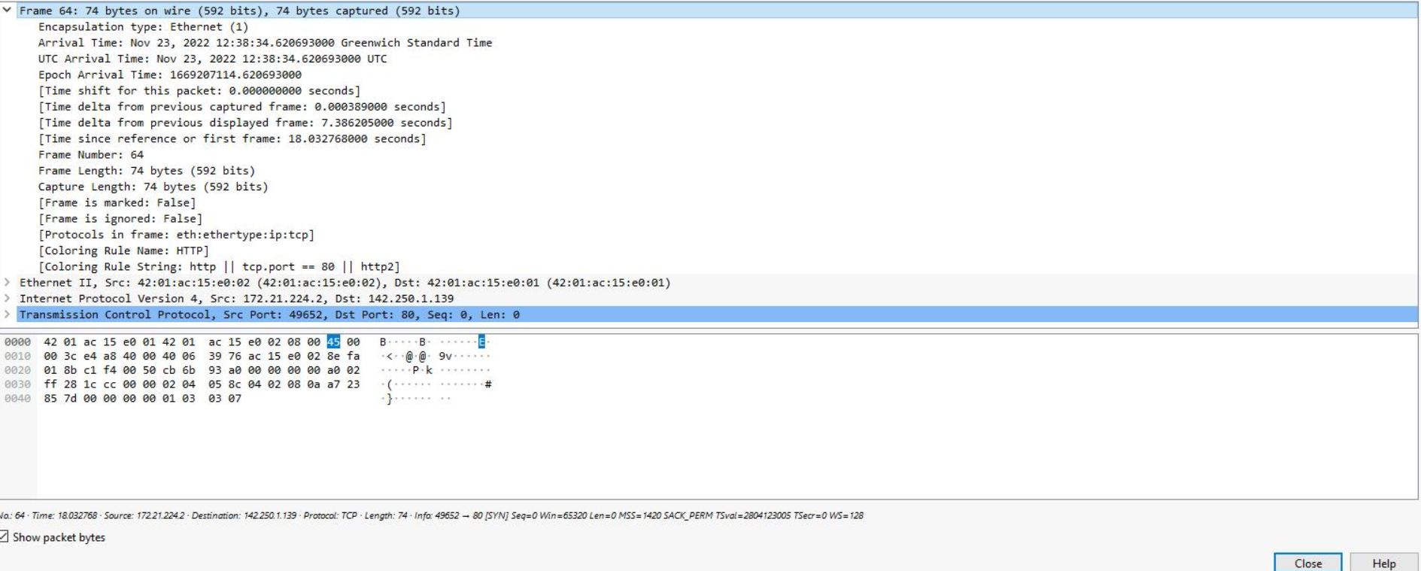

*This provides you with details about the overall network packet, or frame, including the frame length and the arrival time of the packet. At this level, you’re viewing information about the entire packet of data.*

1. *Double-click* ***Frame*** *again to collapse the subtree and then double-click the* ***Ethernet II*** *subtree.*

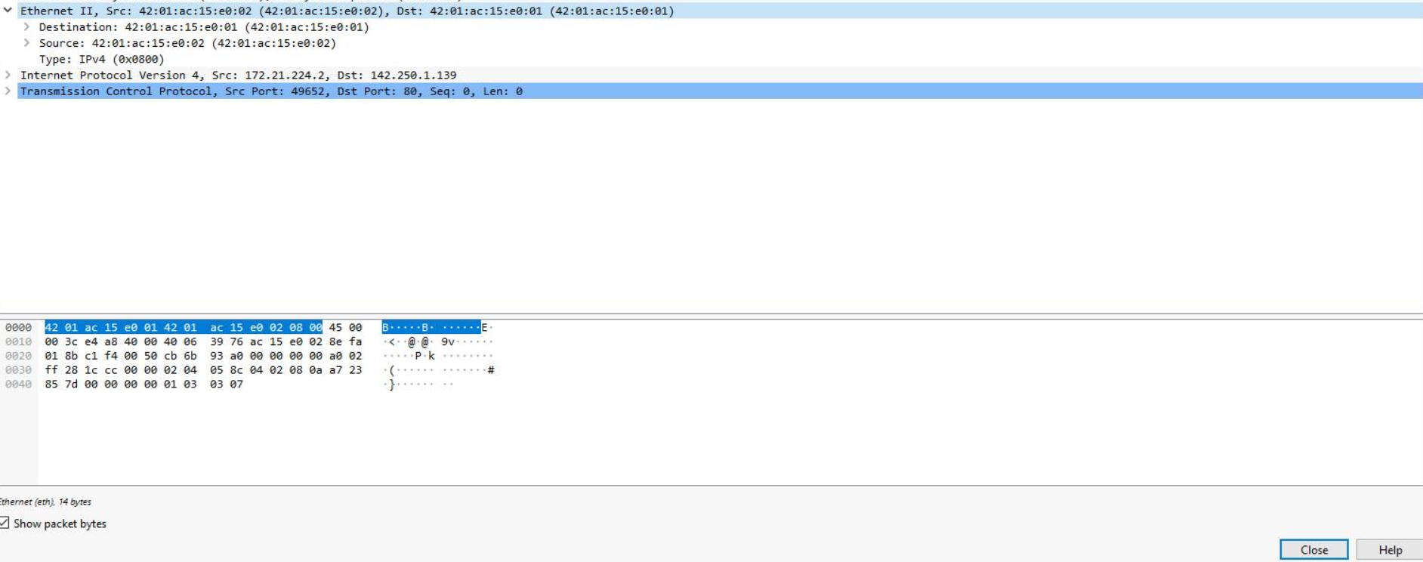

*This item contains details about the packet at the Ethernet level, including the source and destination MAC addresses and the type of internal protocol that the Ethernet packet contains.*

1. *Double-click* ***Ethernet II*** *again to collapse that subtree and then double-click the* ***Internet Protocol Version 4*** *subtree.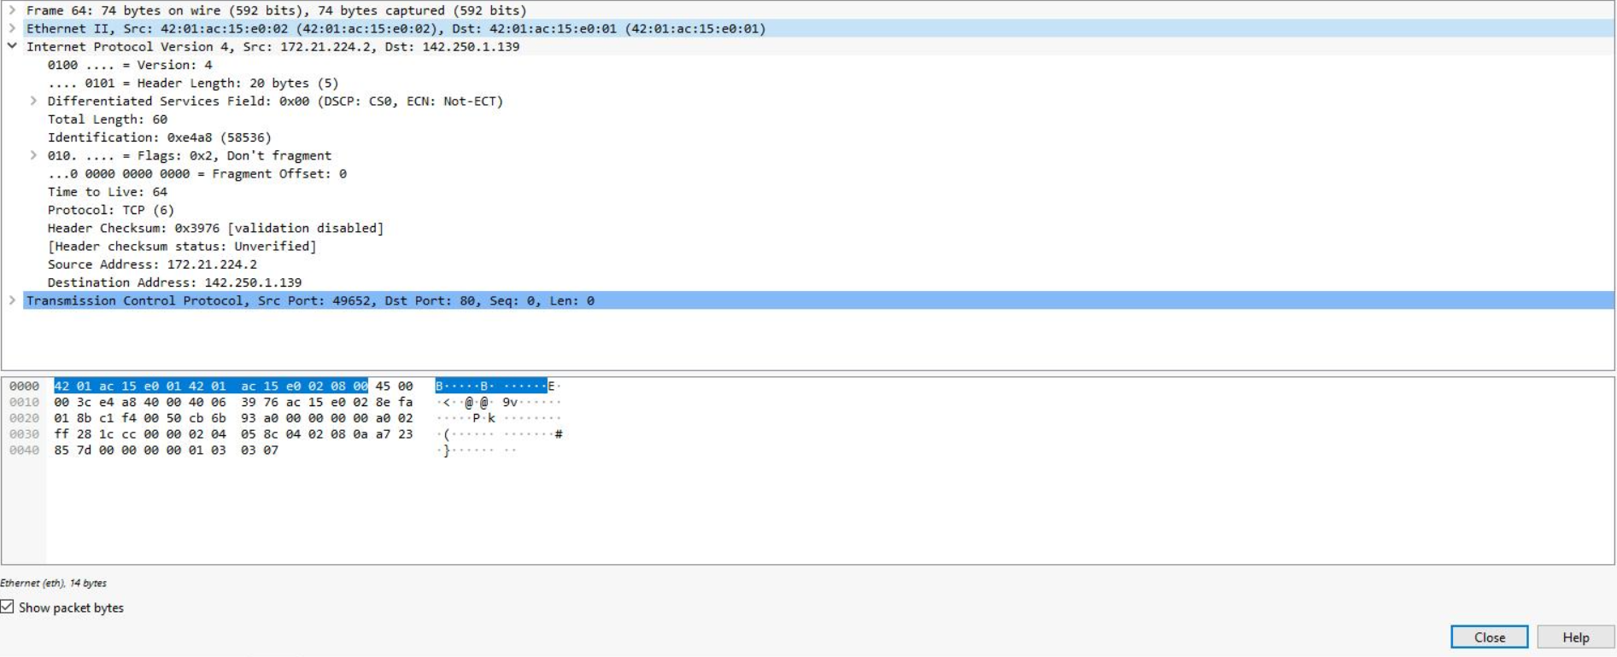*

*This provides packet data about the Internet Protocol (IP) data contained in the Ethernet packet. It contains information such as the source and destination IP addresses and the Internal Protocol (for example, TCP or UDP), which is carried inside the IP packet.*

***Note:*** *The Internet Protocol Version 4 subtree is Internet Protocol Version 4 (IPv4). The third subtree label reflects the protocol.*

*The source and destination IP addresses shown here match the source and destination IP addresses in the summary display for this packet in the main Wireshark window.*

1. *Double-click* ***Internet Protocol Version 4*** *again to collapse that subtree and then double-click the* ***Transmission Control Protocol*** *subtree.*

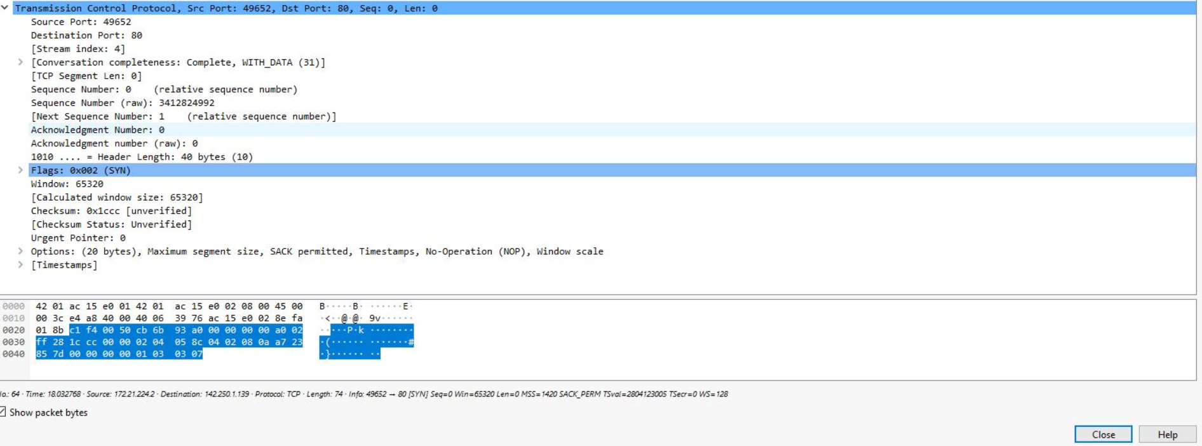

*This provides detailed information about the TCP packet, including the source and destination TCP ports, the TCP sequence numbers, and the TCP flags.*

*The source port and destination port listed here match the source and destination ports in the info column of the summary display for this packet in the list of all of the packets in the main Wireshark window.*

1. *In the* ***Transmission Control Protocol*** *subtree, scroll down and double-click* ***Flags****.*

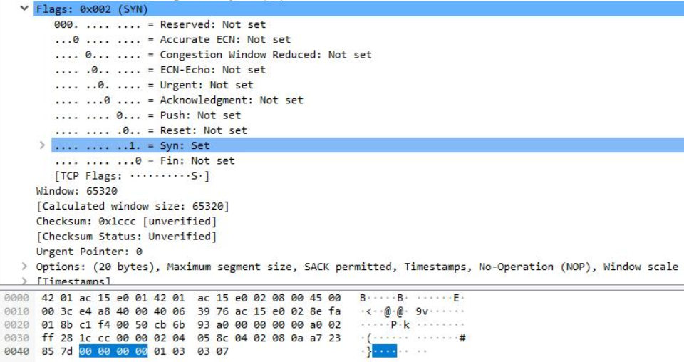

*This provides a detailed view of the TCP flags set in this packet.*

1. *Click the* ***X Clear display filter*** *icon in the Wireshark filter bar to clear the IP address filter.*

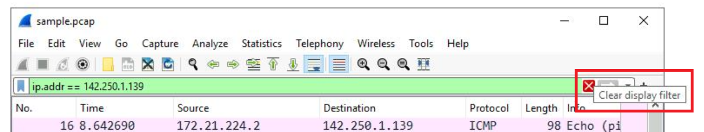

All the packets have returned to the display.

If you ever accidentally close the Wireshark application, you can reopen it by double-clicking the **sample** file on the desktop.

## **Task 3. Use filters to select packets**

In this task, you’ll use filters to analyze specific network packets based on where the packets came from or where they were sent to. You’ll explore how to select packets using either their physical Ethernet Media Access Control (MAC) address or their Internet Protocol (IP) address.

1. Enter the following filter to select traffic for a specific source IP address only. Enter this into the **Apply a display filter...** text box immediately above the list of packets:

ip.src == 142.250.1.139

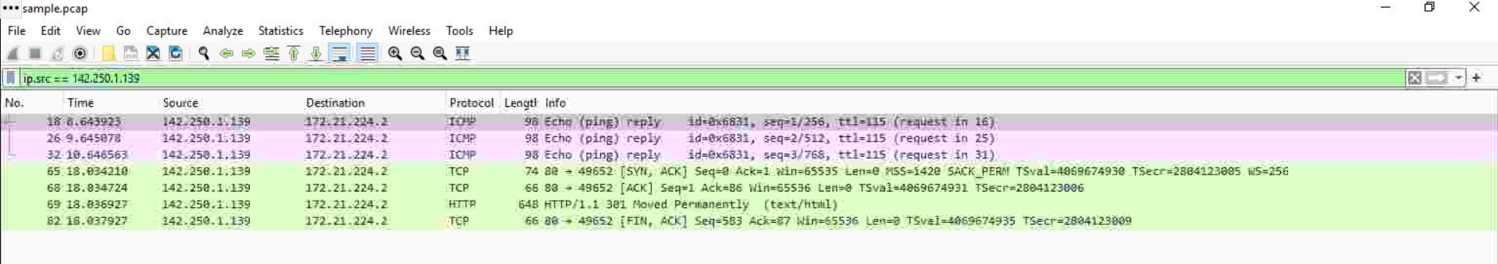

1. Press **ENTER** or click the **Apply display filter** icon in the filter text box.

A filtered list is returned with fewer entries than before. It contains only packets that came from **142.250.1.139**.

1. Click the **X Clear display filter** icon in the Wireshark filter bar to clear the IP address filter.
2. Enter the following filter to select traffic for a specific destination IP address only:

ip.dst == 142.250.1.139

1. Press **ENTER** or click the **Apply display filter** icon in the filter text box.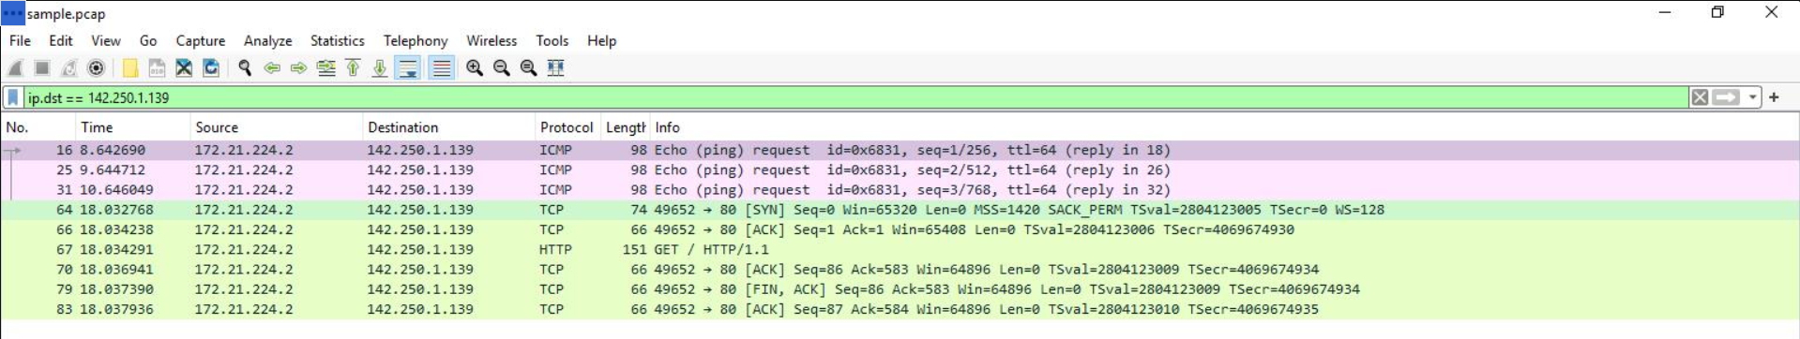

A filtered list is returned that contains only packets that were sent to **142.250.1.139**.

1. Click the **X Clear display filter** icon in the Wireshark filter bar to clear the IP address filter.
2. Enter the following filter to select traffic to or from a specific Ethernet MAC address. This filters traffic related to one MAC address, regardless of the other protocols involved:

eth.addr == 42:01:ac:15:e0:02

1. Press **ENTER** or click the **Apply display filter** icon in the filter text box.

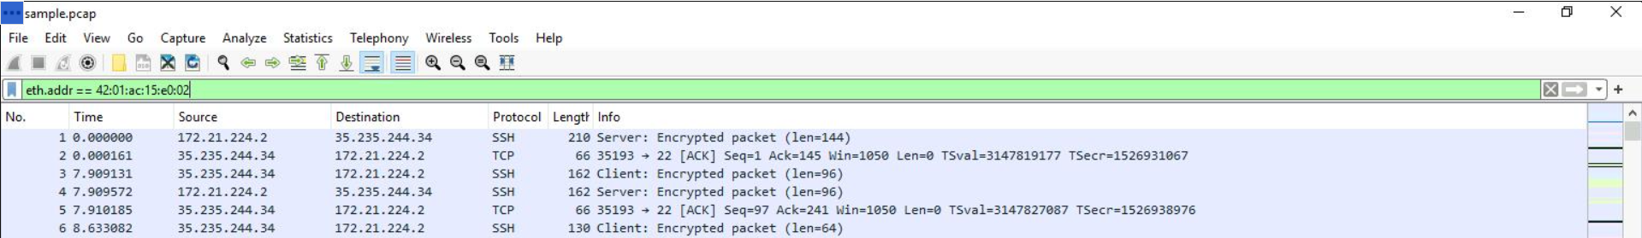

1. Double-click the first packet in the list. You may need to scroll back to display the first packet in the filtered list.
2. Double-click the **Ethernet II** subtree if it is not already open.

The MAC address you specified in the filter is listed as either the source or destination address in the expanded Ethernet II subtree.

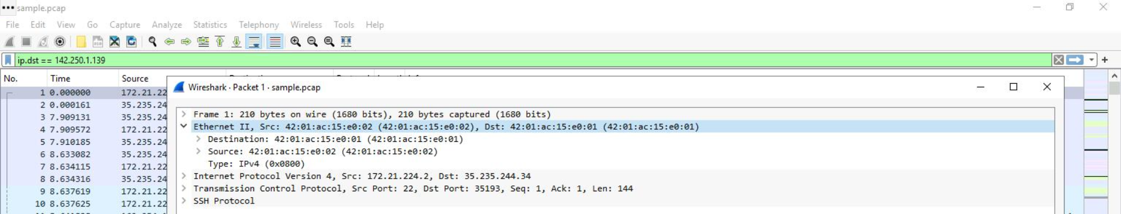

1. Double-click the **Ethernet II** subtree to close it.
2. Double-click the **Internet Protocol Version 4** subtree to expand it and scroll down until the **Time to Live** and **Protocol** fields appear.

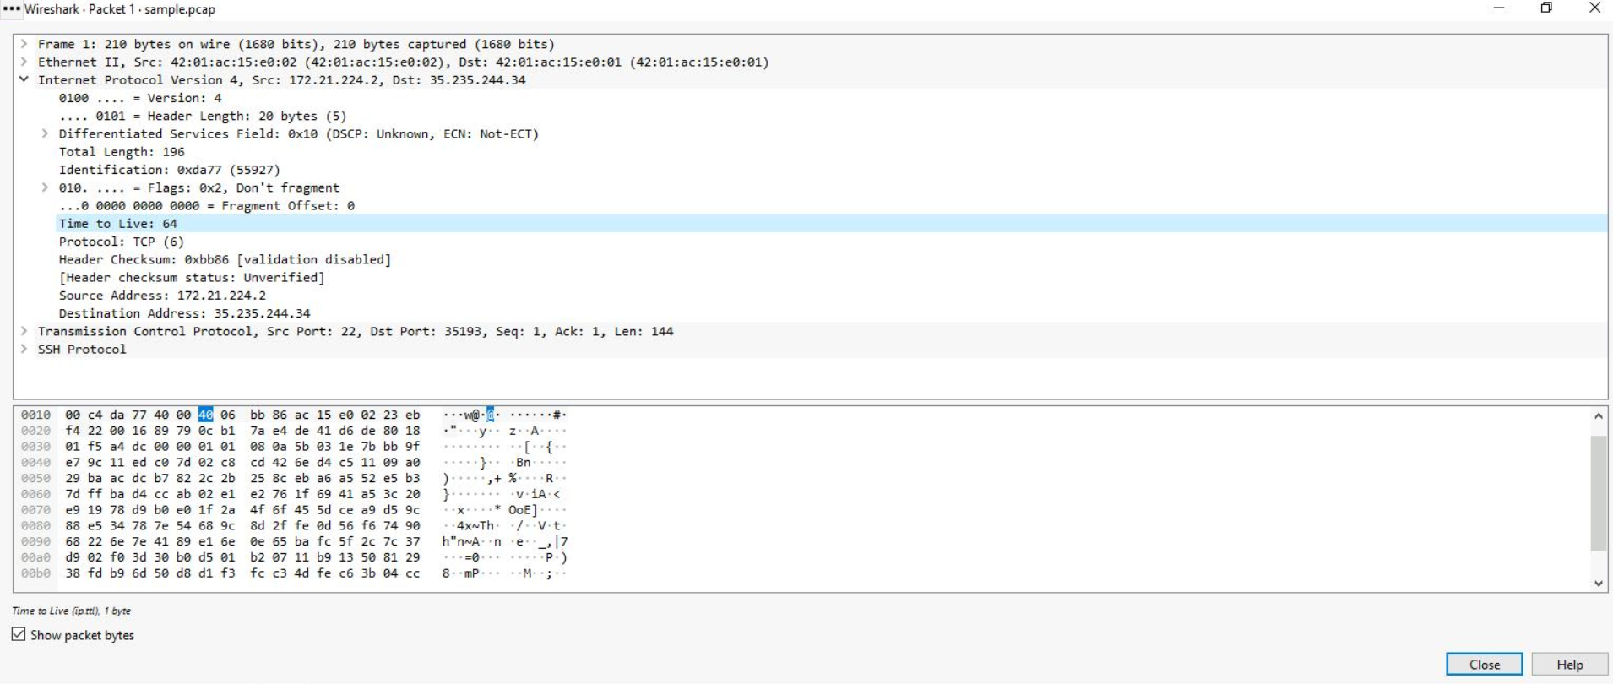

The **Protocol** field in the **Internet Protocol Version 4** subtree indicates which IP internal protocol is contained in the packet.

## ***Task 4. Use filters to explore DNS packets***

*In this task, you’ll use filters to select and examine DNS traffic. Once you‘ve selected sample DNS traffic, you’ll drill down into the protocol to examine how the DNS packet data contains both queries (names of internet sites that are being looked up) and answers (IP addresses that are being sent back by a DNS server when a name is successfully resolved).*

1. *Enter the following filter to select UDP port* ***53*** *traffic. DNS traffic uses UDP port* ***53****, so this will list traffic related to DNS queries and responses only. Enter this into the* ***Apply a display filter...*** *text box immediately above the list of packets:*

*udp.port == 53*

1. *Press* ***ENTER*** *or click the* ***Apply display filter*** *icon in the filter text box.*

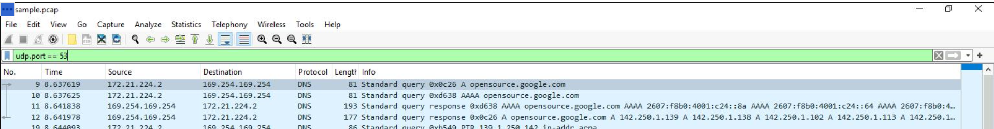

1. *Double-click the first packet in the list to open the detailed packet window.*
2. *Scroll down and double-click the* ***Domain Name System (query)*** *subtree to expand it.*
3. *Scroll down and double-click* ***Queries****.*

*You’ll notice that the name of the website that was queried is* ***opensource.google.com****.*

1. *Click the* ***X*** *icon to close the detailed packet inspection window.*
2. *Double-click the fourth packet in the list to open the detailed packet window.*
3. *Scroll down and double-click the* ***Domain Name System (query)*** *subtree to expand it.*
4. *Scroll down and double-click* ***Answers****, which is in the* ***Domain Name System (query)*** *subtree.*

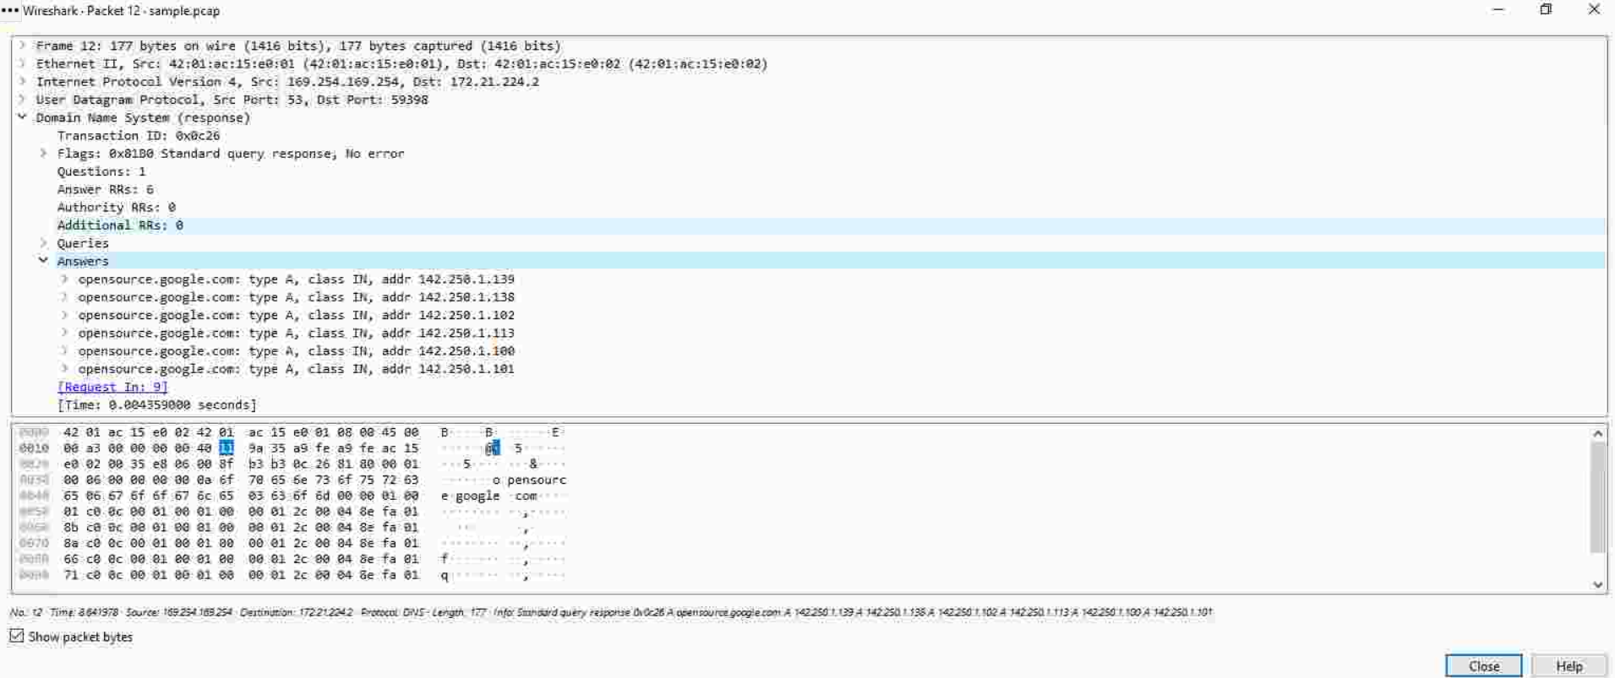

*The Answers data includes the name that was queried (****opensource.google.com****) and the addresses that are associated with that name.*

## ***Task 5. Use filters to explore TCP packets***

*In this task, you’ll use additional filters to select and examine TCP packets. You’ll learn how to search for text that is present in payload data contained inside network packets. This will locate packets based on something such as a name or some other text that is of interest to you.*

1. *Enter the following filter to select TCP port* ***80*** *traffic. TCP port* ***80*** *is the default port that is associated with web traffic:*

*tcp.port == 80*

1. *Press* ***ENTER*** *or click the* ***Apply display filter*** *icon in the filter text box.*

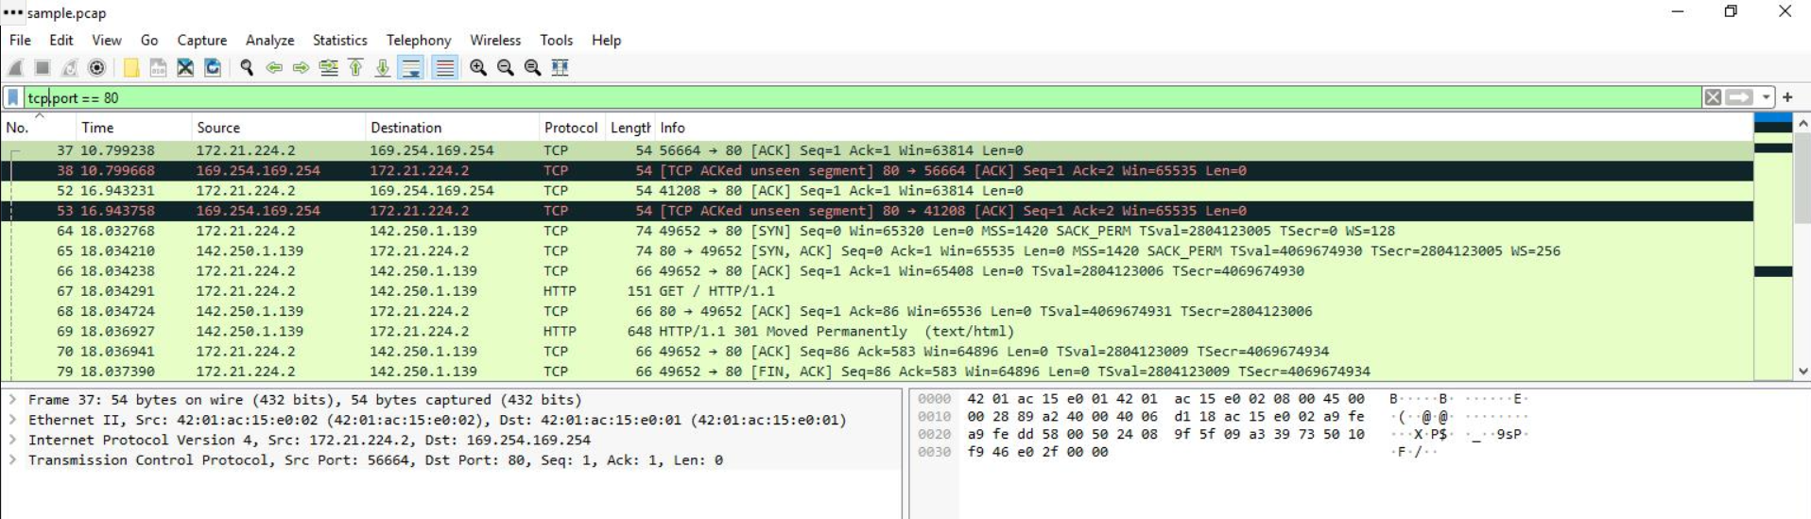

*Quite a few packets were created when the user accessed the web page* ***http://opensource.google.com****.*

1. *Double-click the first packet in the list. The* ***Destination*** *IP address of this packet is* ***169.254.169.254****.*

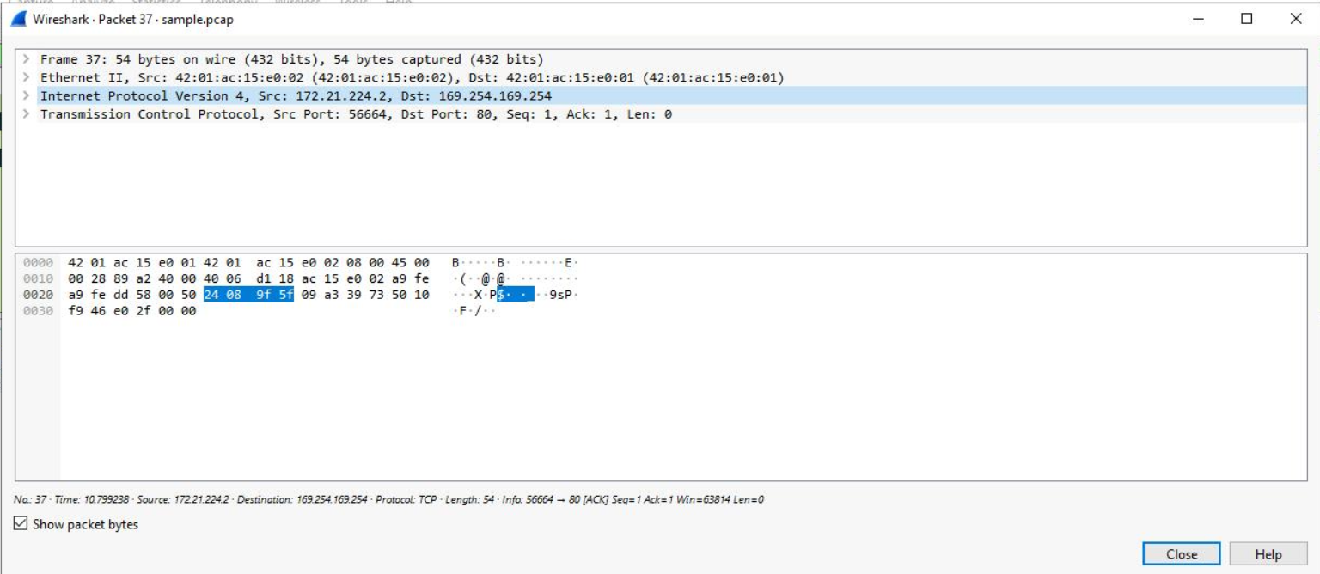

1. *Enter the following filter to select TCP packet data that contains specific text data.*

*tcp contains "curl"*

*5. Press* ***ENTER*** *or click the* ***Apply display filter*** *icon in the filter text box.*

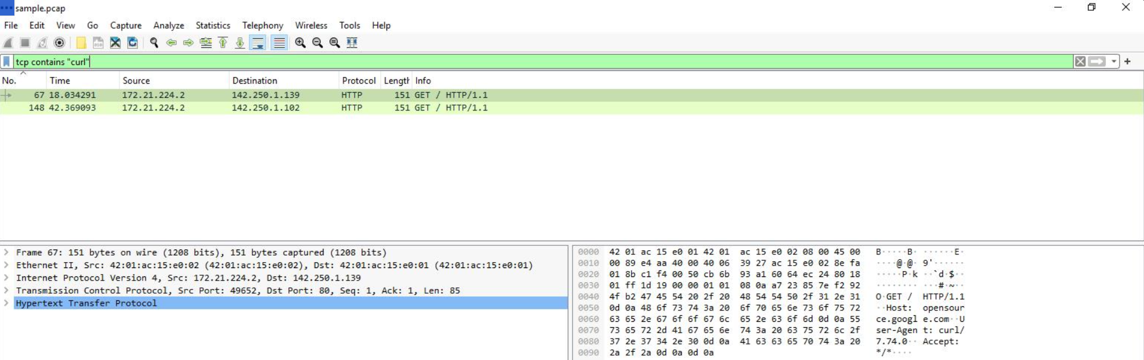

## ***Conclusion***

*I now have practical experience using Wireshark to*

* *open saved packet capture files,*
* *view high-level packet data, and*
* *use filters to inspect detailed packet data.*

*This is an important milestone on my journey toward understanding how to use network packet analysis tools to examine network traffic!*